Supplementary Digital Content 1. Data of arterial gas analysis in oxygen control group or sevoflurane preconditioning group.
Group | MAP | T(°C) | PH | PaO₂(mmHg) | PaCO₂(mmHg)
5 min before MCAO
Control | 99.8.1±2.3 | 37.5±0.1 | 7.42±0.05 | 108.0±2.1 | 39.1±2.3
I/R | 103.2±2.1 | 37.3±0.1 | 7.42±0.02 | 102.3±1.0 | 39.0±1.9
SPC | 102.0±1.2 | 37.4±0.1 | 7.41±0.05 | 104.3±0.9 | 38.2±2.2
30 min after MCAO
Control | 101.2±2.1 | 37.3±0.3 | 7.39±0.06 | 104.3±0.9 | 39.5±1.8
I/R | 102.0±1.9 | 37.0±0.2 | 7.39±0.06 | 109.1±0.8 | 39.6±2.2
SPC | 102.8±1.8 | 37.2±0.2 | 7.41±0.05 | 106.5±1.3 | 38.7±2.4

Using separate mice, data for arterial gas were obtained before, during, and after MCAO operation in sevoflurane preconditioning and oxygen-inhaled groups. There were no significant differences between the two groups at the corresponding time points. All values are expressed as manorial. (n = 5 per group). All values are expressed as Mean ± SD.
SPC = sevoflurane preconditioning; MCAO = middle cerebral artery occlusion; I/R = ischaemia/reperfusion.

Supplementary Digital Content 1. SPC didn’t alter the change of regional cerebral blood flow of ischemic hemisphere during MCAO surgery.
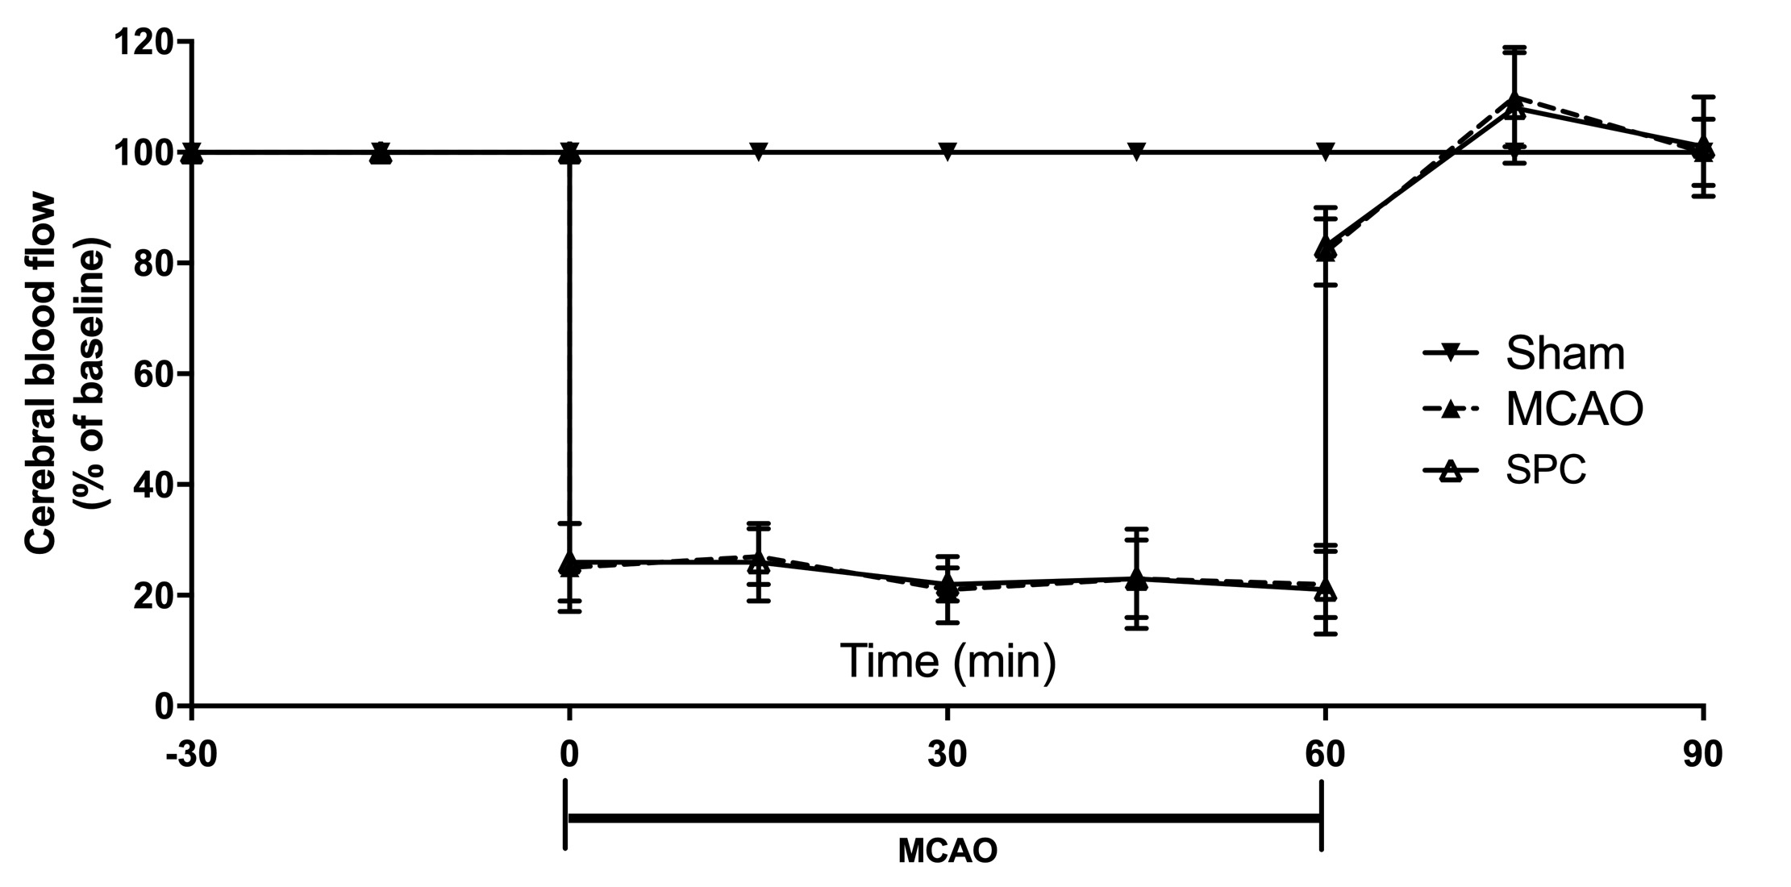
The sevoflurane preconditioning didn’t alter the changes of regional cerebral blood flow induced by MCAO surgery. n = 5 per group. SPC = sevoflurane preconditioning; MCAO = middle cerebral artery occlusion. One-way ANOVA with Tukey’s post hoc test was used for statistic analysis.

Supplementary Digital Content 3. The phosphorylation of GSK-3β was measured by western blot.
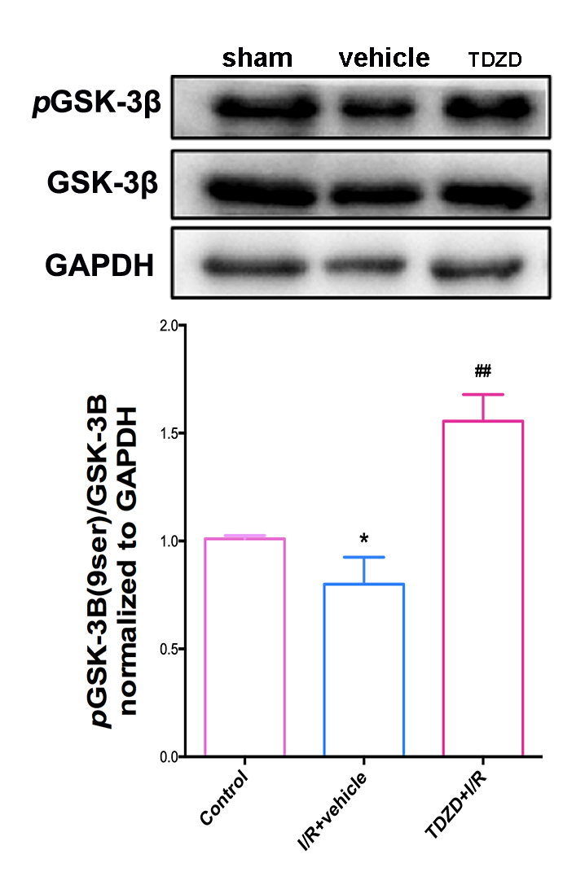
The phosphorylation of GSK-3β at Ser9 was decreased in vehicle-treated I/R groups as compared with control group (P = 0.0210), but this reduction was ameliorated by TDZD-8 supplementation (TDZD+I/R vs. I/R+vehicle, P = 0.0045). One-way ANOVA with Tukey’s post hoc test was used for statistic analysis.
TDZD = 4-Benzyl-2-methyl-1,2,4-thiadiazolidine-3, 5-dione
Supplementary Digital Content 4. The expression changes of Nrf2 aftre AAV-mediated siRNA supplementation.
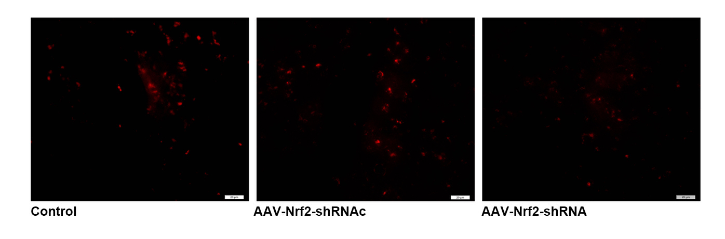
AAV-mediated shRNA knockdown of Nrf2 in hippocampus. (A-C) immunofluorescence labeling showing the expression of Nrf2. Scale bar = 20 μm.

